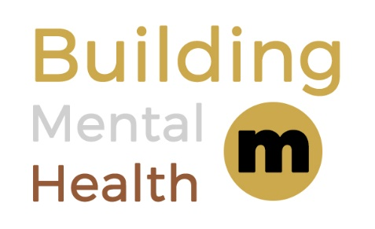

**This is to certify that**



will adopt and commit to the principles of the

**Building Mental Health Charter**

## **Principles**

Our company is signing this charter and pledging to:

* + - Provide awareness and understanding of the impact of poor mental ill health to our workforce and promote positive mental health through facilitated workshops, with the aims of:
      * + Reducing stigma and discrimination
        + Encouraging conversation in the workplace
    - Educate and enable champions from across the workforce to support keeping our people safe
    - Provide access to accredited Mental Health First Aid training and provide assistance to signpost workers to support in their communities
    - Recognise and accept education and training provided by peers and Building Mental Health partners

As a company, we are committing to the Building Mental Health Framework which underpins the values of our business and supports people in our industry, every day, and throughout their working lives.

Name – Title

Organisation

Sign up Year

**2021**

[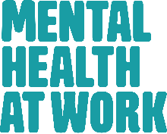](https://www.google.co.uk/url?sa=i&rct=j&q=&esrc=s&source=images&cd=&cad=rja&uact=8&ved=2ahUKEwjOicv6nbPeAhWrB8AKHSEbD0gQjRx6BAgBEAU&url=https://www.mentalhealthatwork.org.uk/&psig=AOvVaw1XxQ7sXLAlyiRihELOLZtO&ust=1541163063092019)



­