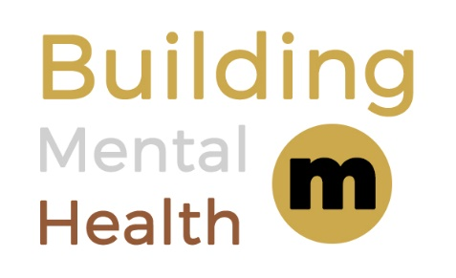

This is to certify that

will adopt and commit to the principles of the
Building Mental Health Charter

Principles

Our company is signing this charter and pledging to:

    - Provide awareness and understanding of the impact of poor mental health to our workforce and promote positive mental health through facilitated workshops, with the aims of:
        - Reducing stigma and discrimination
        - Encouraging conversation in the workplace

    - Educate and enable champions from across the workforce to support keeping our people safe

    - Provide access to accredited Mental Health First Aid training and provide assistance to signpost workers to support in their communities

    - Recognise and accept education and training provided by peers and Building Mental Health partners

As a company, we are committing to the Building Mental Health Framework which underpins the values of our business and supports people in our industry, every day, and throughout their working lives.
Name – Title
Organisation
Sign up Year
2020

